**CMS PBJ Nurse Staffing Analysis Report**  
**Prepared by Clipboard Health**

**1. Objective**

* Evaluate contractor vs. employee staffing patterns across nursing facilities.
* Identify facilities and states with high reliance on contractor staff.
* Visualize trends in contractor usage to inform staffing strategies and compliance monitoring.

**2. Datasets Used**

* **PBJ Daily Nurse Staffing Q2 2024**: Daily staffing hours (RN, LPN, CNA) split into employee and contractor hours.
* **NH Provider Info Nov 2024**: Facility metadata (e.g., state, county, provider details).

**3. Key Steps & Methodology**

**Data Preparation**

* **Standardized Facility IDs**: Renamed columns for consistency and converted Facility_ID to string type.
* **Merged Datasets**: Combined staffing and provider data using a left join on Facility_ID.

**Staffing Analysis**

* **Contractor vs. Employee Hours**: Calculated the percentage of contractor hours for RNs, LPNs, and CNAs per facility.
* **High-Contractor Facilities**: Flagged facilities where >50% of hours for any role came from contractors.  
  **Result**: 1,026 facilities identified.

**State-Level Trends**

* **Total Hours Aggregation**: Summed contractor and employee hours by state.
* **Contractor Percentage**: Calculated overall contractor usage per state.  
  **Top States**:
  + **VT (32.0%)**
  + **ME (18.1%)**
  + **NJ (15.6%)**
    1. **Key Findings**
* **Top 10 High-Contractor-Use Facilities:**

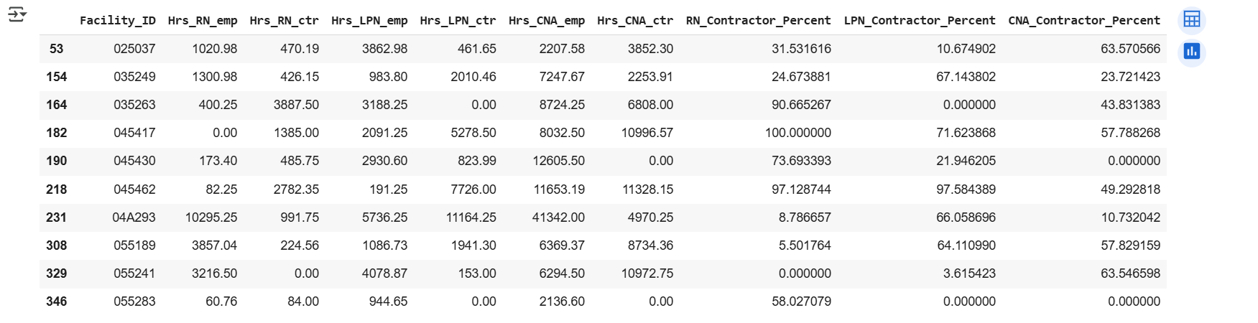

* **States with Highest Contractor Usage:**

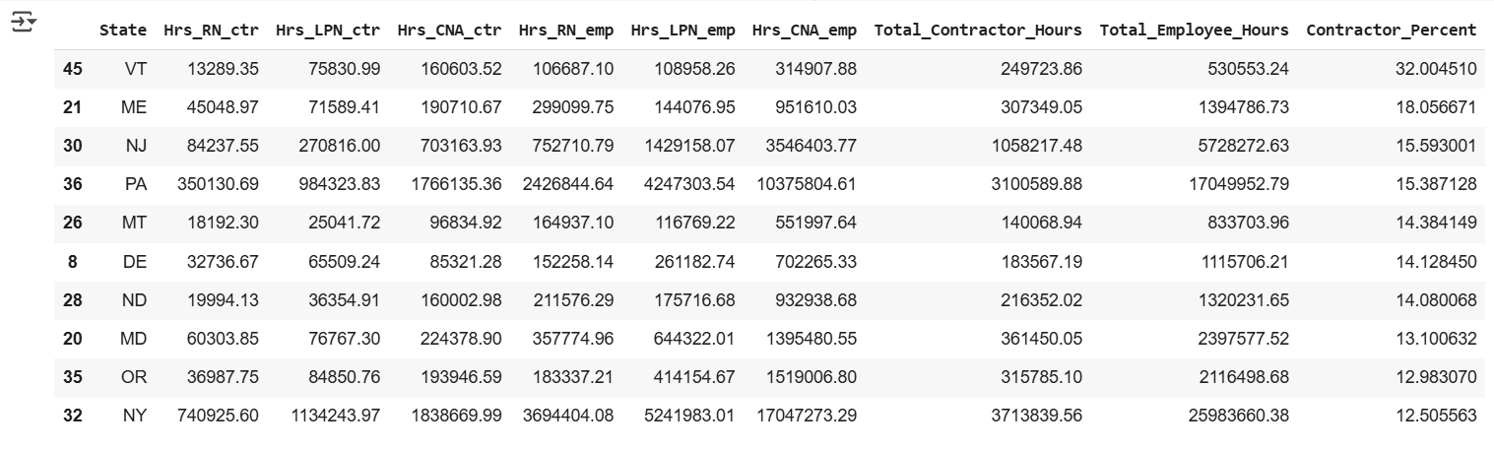

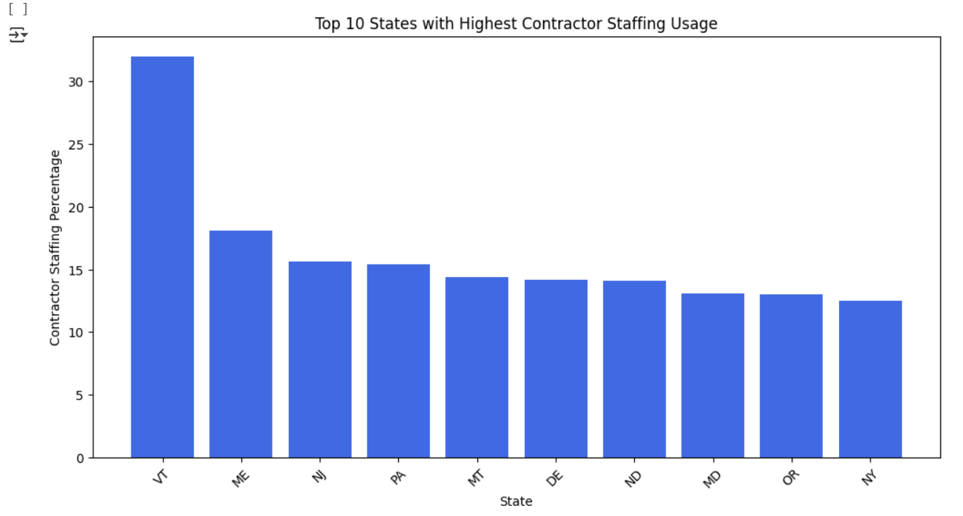

* **Top 10 Nursing Homes with the Highest Contractor Usage**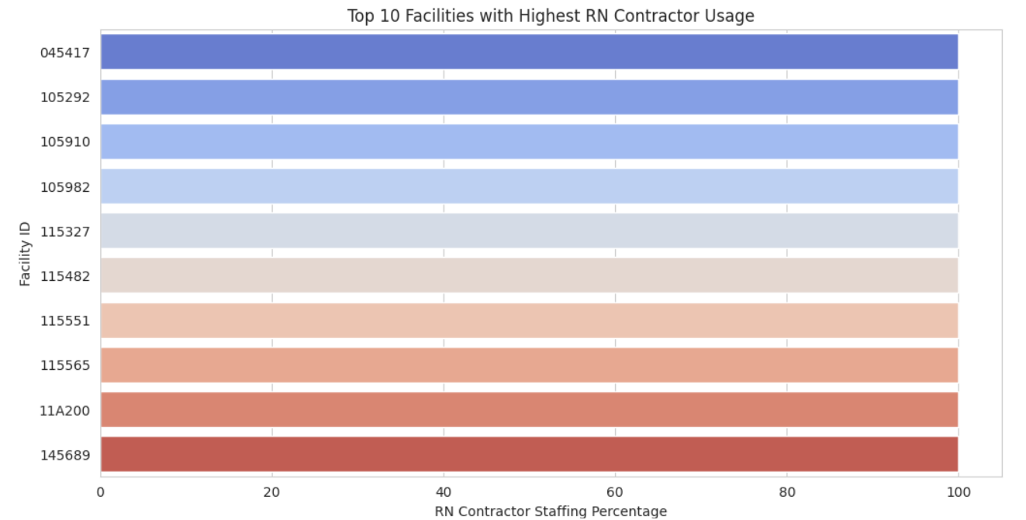
* **Heatmap of Contractor Usage by Job Role**

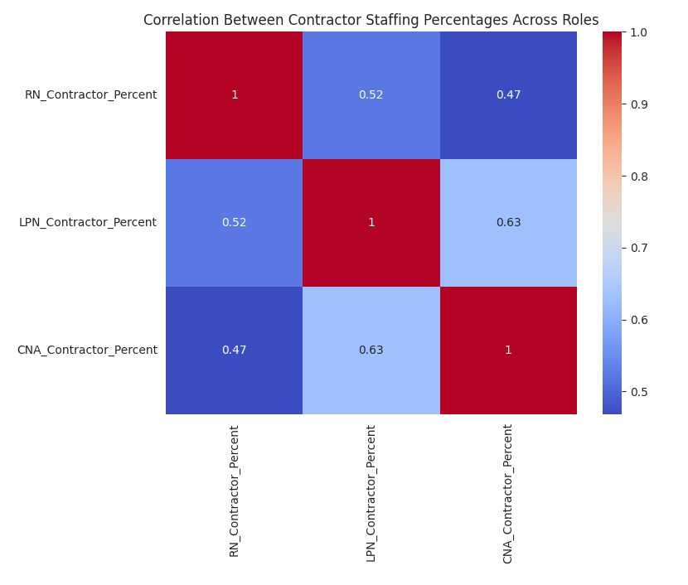

* **Pie Chart of Total Contractor vs. Employee Staffing**

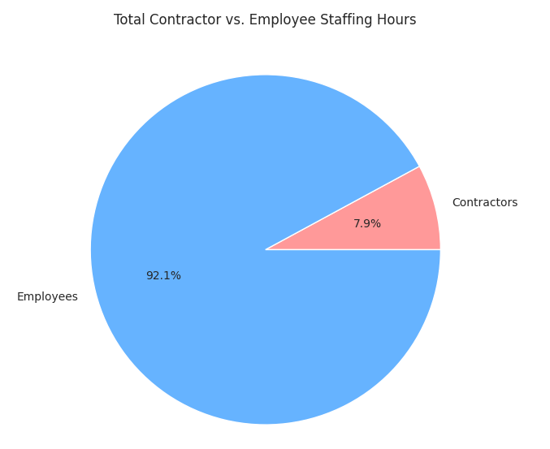

* + 1. **Sales Recommendations**

**1️. Prioritize High-Demand States**

* Focus on states where contractor staffing is highest, as these represent the biggest opportunities for growth.
* Expand Clipboard Health’s network of healthcare professionals in these regions to meet demand.

**2. Target Facilities with Heavy Contractor Usage**

* Nursing homes where contractors exceed 50% of total staffing hours should be prioritized for outreach.
* These facilities likely need ongoing staffing support, making them high-value clients.

**3️. Monitor Contractor Usage Trends**

* If available, analyze historical trends to identify emerging markets for expansion.
* A steady increase in contractor staffing indicates long-term demand, while a decline may suggest changes in hiring strategies.

**Next Steps**

🔹 **Refine target lists**: Focus on high-demand states and top contractor-reliant facilities.  
🔹 **Expand staffing network**: Increase the supply of contract nurses in key regions.  
🔹 **Track quarterly trends**: Use historical data to adjust sales strategies as contractor demand shifts.